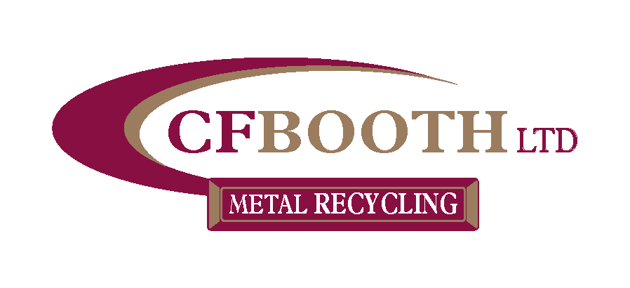

Sustainability Policy

CF Booth has grown over the years from a local metal trader into one of the largest independently run recycling companies in Europe. CF Booth Ltd is the head company of the CF Booth group of companies.

The scope of this policy applies to CF Booth Ltd.

We strive to deliver sustainable solutions guided by our values and our Sustainable Development Management Plan and Implementation Framework. With this, we engage with our teams, customers and supply chain for the benefit of those stakeholders in the wider community and environment in which we work and live. It is important to us to emphasis the social, economic and environmental impact of our business in everything we do, and this policy reflects our commitment to ensuring that sustainability is considered through all our business decisions.

Our Sustainable Development Management Plan and Implementation Framework provides the structure to embed sustainability into our business to implement the following sustainability pledges. CF Booth will:

- Use fewer material goods, where possible, use locally produced goods and services, minimising waste and maximising water energy and transport efficiency. Improve resource efficiency, sustainable consumption, and production, throughout the whole supply chain.

- Protect air, water, soil and biological resources and exceed our legal obligations in this respect.

- Engage with civic projects and the local communities in which we work, both through specific project engagement and through company-wide initiatives.

- Offer career development, supporting our teams to be diverse, engaged, motivated and competent and working together towards the sustainable success of our business

- Deliver sustainable profitable growth while satisfying our ethical, legal and contractual obligations.

- Encourage ideas and innovation, internally and with our supply chain, that can create financial savings and benefit our customers, society and environment.

- Actively promote sustainability in our industry through the industry associations, partnerships and organisations we support.

- Demand sector-leading Health, Safety and Environmental performance from our own teams and our subcontractors

- Integrate our sustainability goals throughout our operations.

- Commit to measuring our impact through Health, Safety and Environmental performance data, employee engagement surveys, customer satisfaction feedback and our financial performance.

This policy will be reviewed annually and be updated if changes to the company occur. This policy will be communicated to all staff and will be made available to members of the public on request.

This policy is hereby authorised by:

J. H. Booth - Director
16th^{st} January 2023

